Navigating 7th Grade Science Resources

Step 1: Go to Lakeview Website (www.lakeviewpublicschools.org)

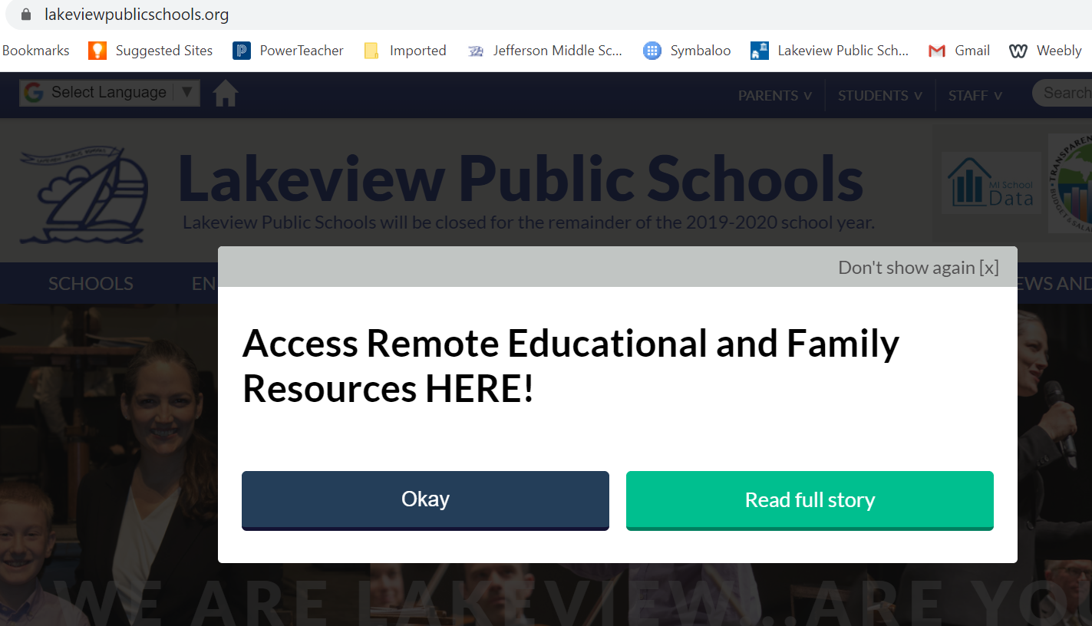

Step 2: Click on “Read Full Story”

Step 3: Click on “Click here to access STUDENT Educational Resources”

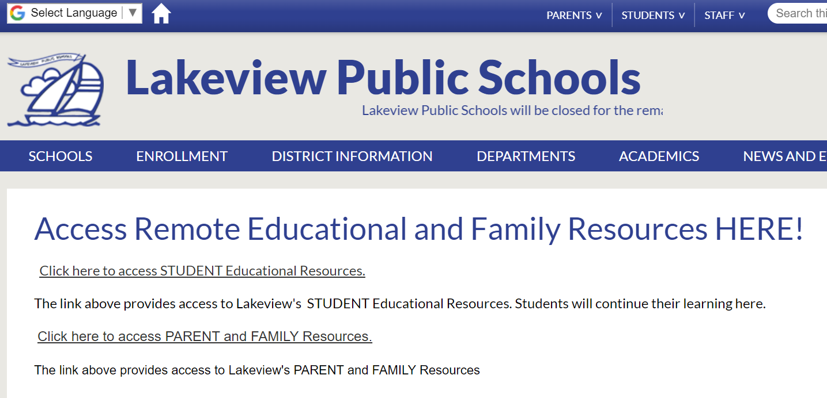

Step 4: A Google Drive will open on the screen. Double click on “JMS”

Step 5: Different folders will show on the screen (different subjects, etc.) Double click on the “Science” folder.

Step 6: Click on the PDF for the Weeks needed.
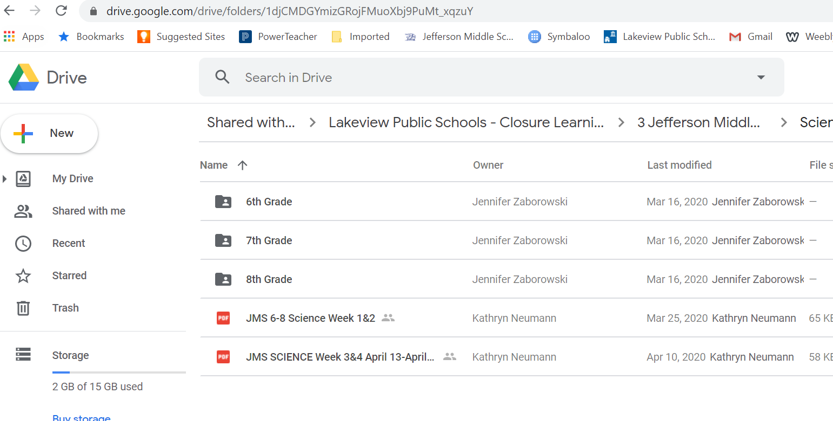
Step 7: The activities for the week will appear. Each of the activities listed are hyperlinks to directions or websites.
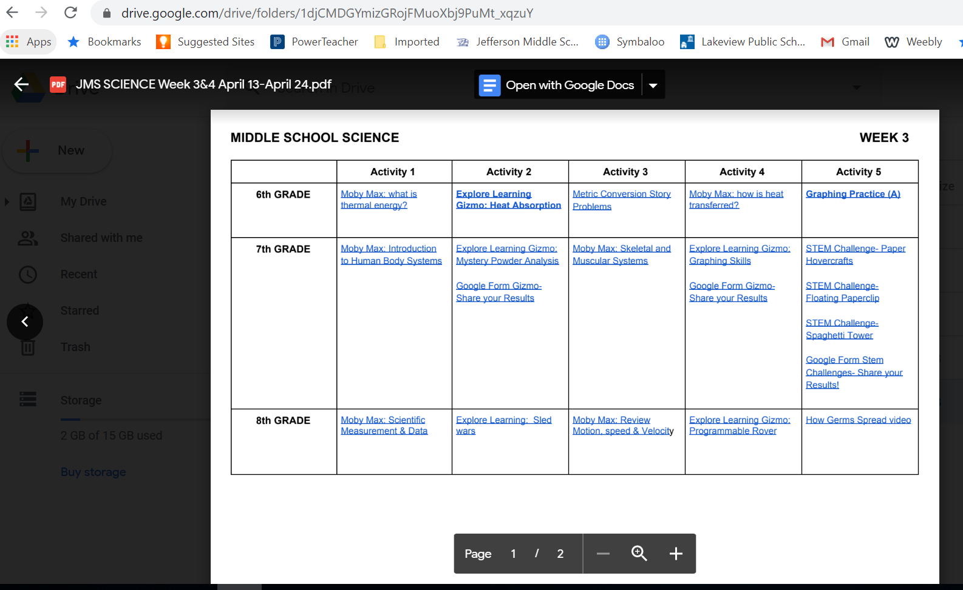

Step 8: For Moby Max assignment, click on the blue hyperlink for that specific activity.

Step 9: Directions for Login/Password information will appear AND specific instructions of what to complete. All answers will be recorded in Moby Max.

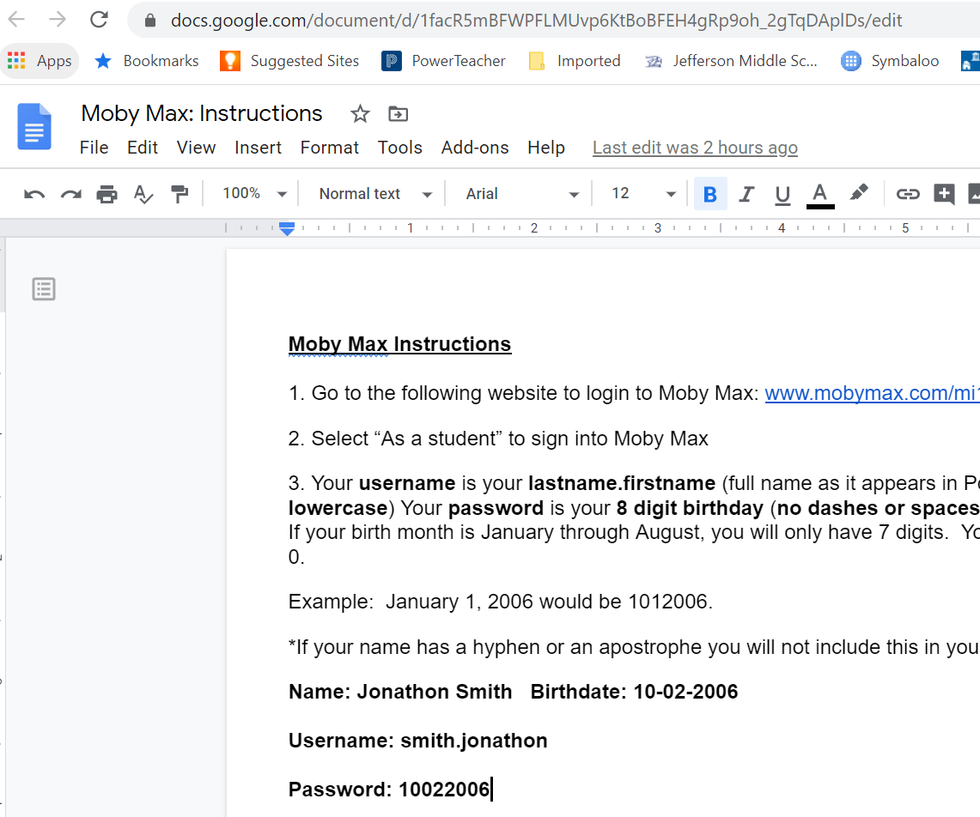

Step 10: For Explore Learning Website, click on a blue hyperlink for that specific activity.

Step 11: Directions for Login/Password information will appear. Make your own login/password.

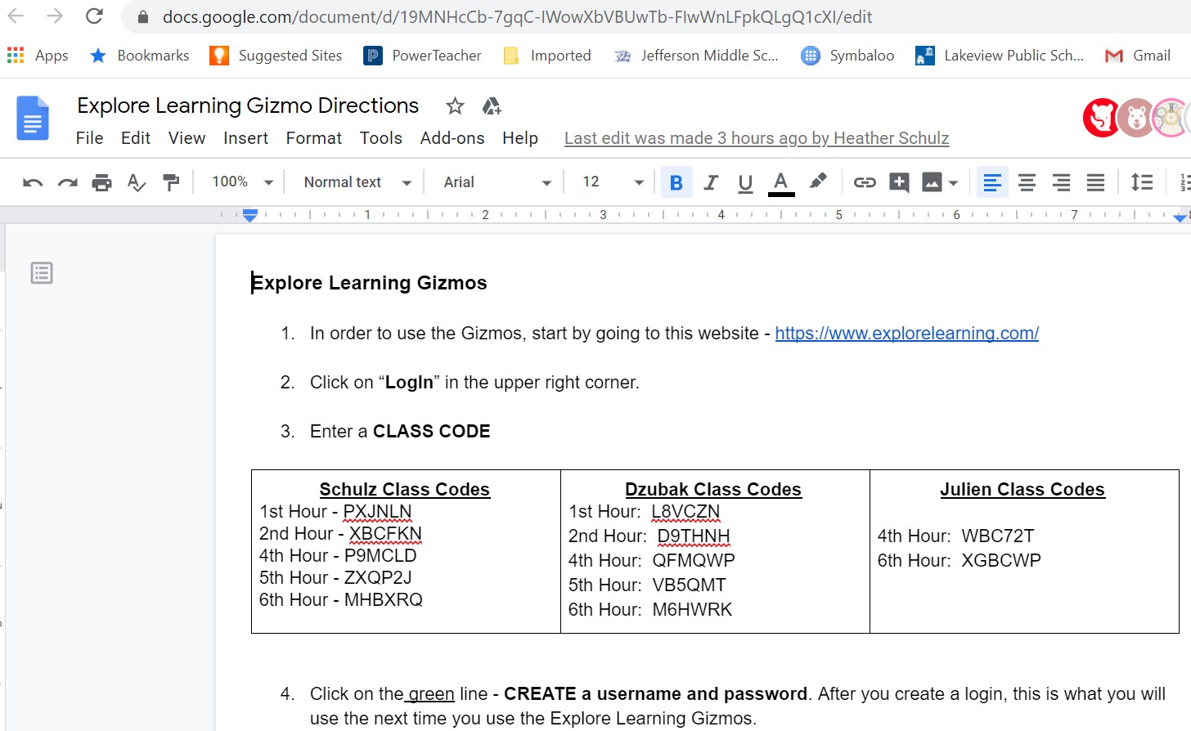

Step 12: After you have completed your login/password. Complete the assignments listed on the directions sheet for the Gizmo. The assignments for “Explore Learning” are listed on the directions sheet, just scroll down.
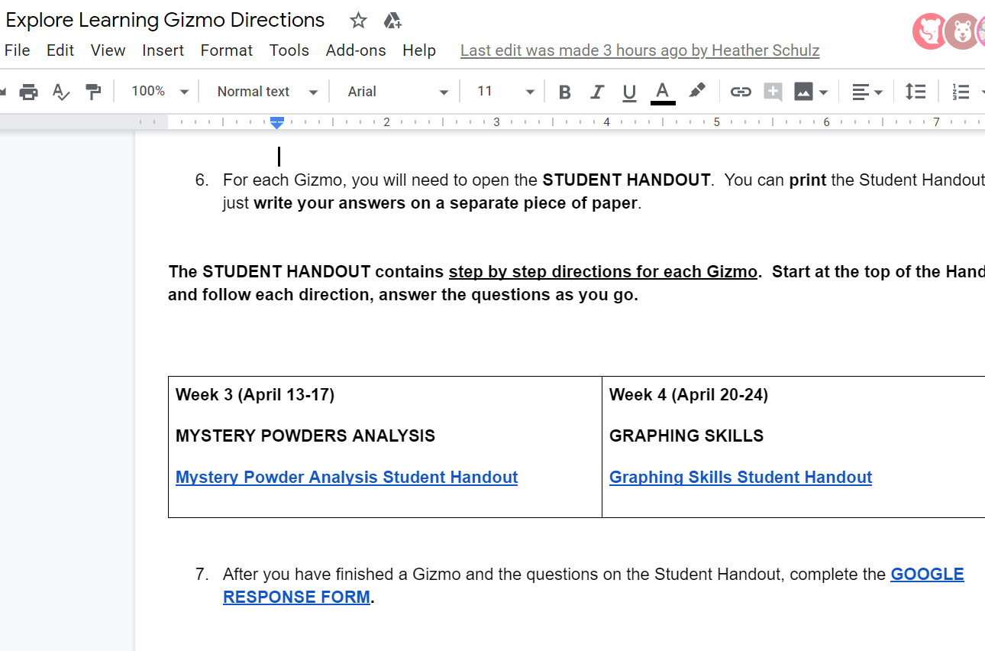

Step 13: Follow the step-by-step instructions to complete the Explore Learning Gizmo. These instructions can be printed OR you can write the answers down on a sheet of paper.

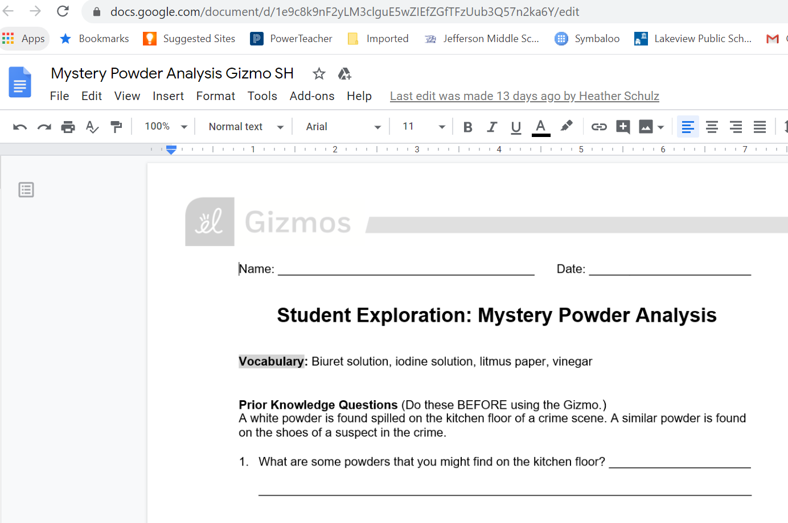

Step 14: After you have completed the Gizmo, take a picture of your answers and you can upload them using the Google Form, send pictures through Remind texting OR email.

Step 15: For the STEM Challenges, click on the blue hyperlink to access the video or online instructions.

Step 16: After you have completed the STEM challenges, complete the google form.

