Name ______________________________________ Monday’s Date_____________ Hour_______

You **MUST** **copy** the **question if given on the board** and answer it using complete sentences.

|  |  |  |  |  |  |  |  |  |  |  |  |  |  |  |  |  |  |  |  |  |  |
| --- | --- | --- | --- | --- | --- | --- | --- | --- | --- | --- | --- | --- | --- | --- | --- | --- | --- | --- | --- | --- | --- |
| **”Chart”ering New Territory Tuesday**  **(Charts and Graphs)**  **Construct a data table from the information given below. Make sure your data table includes a title, category headings, proper units and an average column.**  **You are a biologist studying the health of bald eagles in three states: Alaska, Washington and Montana. You come up with the following data:**   * **In Alaska the 3 bald eagles had a mass of 6.5 kg, 6.9 kg and 6.1 kg.** * **In Washington the 3 bald eagles had a mass of 6.2 kg, 7.3 kg, and 5.6 kg.** * **In Montana the mass of the eagles were 4.1 kg, 8.1 kg and 5.1 kg.** | **”Chart”ering New Territory Tuesday**  **(Charts and Graphs)**  Title: ____________________________________   |  |  |  |  |  | | --- | --- | --- | --- | --- | |  |  |  |  | Average  (kg) | | Alaska |  |  |  |  | |  |  |  |  |  | |  |  |  |  |  | |
| **Teacher’s Choice**  **“Throwback Thursday”**    1. 3,000 m = ________ g 2. 105 km = _________ m    3. 7 L = ________ mL 4. 7.6 m = _________ cm  5. 2.5 g = _________ mg 6. 78 mL = _________ L  7. 198 g = _________ kg 8. 1,500 m = ________ km | http://blog.entrepreneurthearts.com/etablog/wp-content/uploads/2011/09/vocabulary.gif  **Flocabulary Friday**  1. Create 2 notecards for the following words:   * Matter * Atom * Molecule   2. Notecards should include the following:   * Word * Picture (colored) * Definition * Examples (at least 2) * Neatly done |

WEDNESDAY WILD WRITING EXPLORATION (on back)

WEDNESDAY WILD WRITING EXPLORATION!

|  |  |
| --- | --- |
|  | I have read over my response now that I have finished writing it. |
|  | I restated the statement/question in my response **(HIGHLIGHT IN GREEN)** |
|  | I provided supporting details **(HIGHLIGHT IN YELLOW)** |
|  | I used transition words |
|  | I used proper punctuation and capital letters where needed |
|  | My concluding sentence brings all of the ideas together **(HIGHLIGHT IN PINK)** |
|  | I wrote so neat, others can read it |
|  | My response makes sense and is accurate/relevant. |

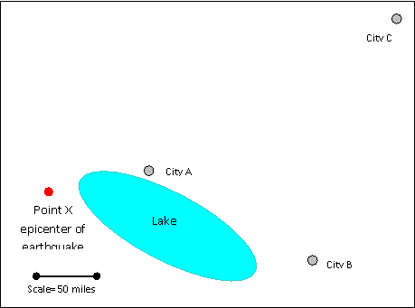**Directions:** Answer the following question. Be sure to use the rubric provided to check your writing after you have answered the question. **Scenario:** The map below represents an area affected by a medium sized earthquake. The epicenter is at Point X on the map. Buildings in City A experience collapsed floors, cracked foundations and crumbling walls. Buildings in City B experience some minor wall and foundation cracks. In City C people report buildings swaying slightly but no visible cracking of walls or foundations.

**Question:** Explain why people living at City C felt the earthquake when they were farther away from the epicenter of the earthquake.

_______________________________________________________________________

_______________________________________________________________________

_______________________________________________________________________

_______________________________________________________________________

_______________________________________________________________________

_______________________________________________________________________

_______________________________________________________________________

_______________________________________________________________________

_______________________________________________________________________